ENPH 353 Logbook

January 13, 2023

* Setting up the linux harddrive on the USB
  + 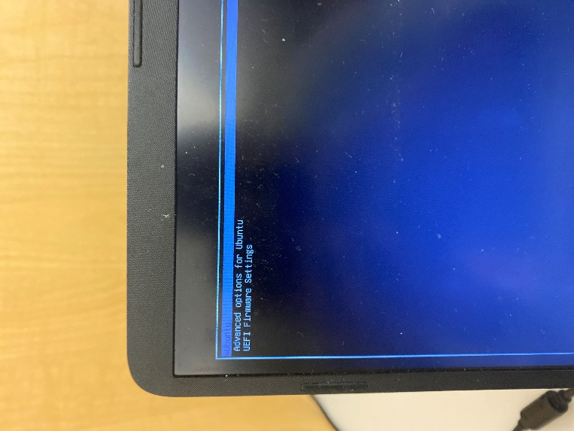When I open the laptop, I think I just need to spam F12 upon opening to open Linux
  + Download 1
    - I think I tried F9 or F10 or something like that, and it opened the boot up basis for my HP laptop
    - There I played around with a few things, but the main thing I did was go to the boot up section, and select the USB that was plugged in
    - In doing so, I got the XUbuntu logo to pop up and entered the password
    - But it opened up to this page on the right, and from there I had no idea what to do
    - I tried a few things but failed to find any success
  + Download 2
    - So I reflashed the file onto the USB
    - This took obnoxiously long as I thought my Windows laptop was connected to wifi, but it was actually having crappy connection to ShawOpen
      * As an aside, I setup ubc secure’s VPN/application, and got that connected
      * Now the wifi is fairly secure and consistent
      * But I don’t know if I need to run the application again, or if it ever times out? Or if I am just good to go from now on.
    - After plugging it in, my friend told me to spam the F12 key when loading, and it worked!
    - I got exactly as expected
    - Followed the rest of the lab and ran the simulation successfully
* The rest of the lab went smoothly, nothing super exciting
  + I tried downloading a password manager but it was giving me some troubles so I didn’t continue with it
  + I also tried to change the password but am more scared that I will forget the password, I need to remember to change the password